CHAPTER 1
EXECUTIVE SUMMARY/ABSTRACT
  - The company (Profile)

DigiToad Technologies was found in 2018 .
- DigiToad Technologies offers products, training services, and technology solutions for engineering systems applications specific to robotics & control systems, machine vision, signal, image & video analytics, wireless sensor networks, the internet of things, machine learning & artificial intelligence. It is based in Bangalore, India.
- DigiToad Technologies headquarters is located at AB square #617, 5th main OMBR layout, Bangalore.

Specialties : Embedded Software, Internet of Things, Edge AI, Machine Learning, Wireless Technologies.


Fig 1: DigiToad Technologies

1.2 The problem or opportunity or area of Internship work
- The opportunities and the area of internships that are available in DigiToad Technologies are Embedded Software, Internet of Things, Edge AI, Machine Learning, Wireless Technologies.
- The internship that is currently provided is Embedded AI Design.
- The problem with the internship is that the tool used in the designing is licensed and the components used in the interfacing are not affordable if they are damaged.
- The installation takes more time in case of NanoEdge AI Studio.
- Detecting the samples maybe be difficult if there is external noise.

1.3 Methodology
- To start with Embedded AI design, installation of Embedded AI development tool chain is mandatory.
- In this the main tool for designing is NanoEdge AI Studio and the programming part requires Arduino 1.8.19
- The codes required for the hardware interfaces are taken from different url’s mentioned by the instructor like:
shorturl.at/fmvJO- where codes for LED interfacing are available.
- Different libraries are also included in the Arduino which are required for the interfacing and hardware purposes.

ARDUINO :
- While using Arduino we have to set the required board (nucleo-64), board part number and port.
- The board part number is different for different STM32 microcontroller.
- In Arduino preferences the STM32 Arduino github get started code should be added in additional code preferences in order to get access of different libraries.
- Different libraries should be included in the Arduino using zip files or extracted files.

NANOEDGE AI STUDIO :
For converting an analog signal to digital signal or for any audio signal transmissions the following steps has to be done:
N-class classification
- Project settings
- Signals
- Benchmark
- Emulator
- Validation
- Deployment

1.4 Benefits to the company/institution through your report.
The benefits to the company is that it helps to know the manufacturing and industrial settings, pairing embedded AI and the Internet of Things which result in predictive maintenance for equipment, increased operational efficiency, improved products and services, and enhanced risk management.

The institution can have an idea about the company and the internship which is provided by them and to what extent it is useful for gaining industrial experience.

CHAPTER 2
INTRODUCTION
2.1 History
- The Embedded AI Design is started in order to have highly optimized, low footprint machine learning algorithms that run on ultralow power microcontrollers.
- The microcontroller which is used is STM32 microcontroller.
- The STM32 is the third ARM family by STMicroelectronics.
- This approach is particularly useful in ‘always-on’ applications where power consumption needs to be minimized and invasion of privacy is a serious concern.
- These Embedded AI Design technologies are used for having a low power consumption products.

2.2 Definitions
- Embedded artificial intelligence (AI) is the application of machine and deep learning in software at the device level. Software can be programmed to provide both predictive and reactive intelligence, based on the data that is collected and analyzed.
- STM32 is a family of 32-bit microcontroller integrated circuits by STMicroelectronics.
- STM32 microcontrollers offer a large number of serial and parallel communication peripherals which can be interfaced with all kinds of electronic components including sensors, displays, cameras, motors, etc. All STM32 variants come with internal Flash memory and RAM.
- GPIO stands for general purpose input/output. It is a type of pin found on an integrated circuit that does not have a specific function. the function of a GPIO pin is customizable and can be controlled by the software.

2.3 Architecture/Block Diagram/Pin Diagram

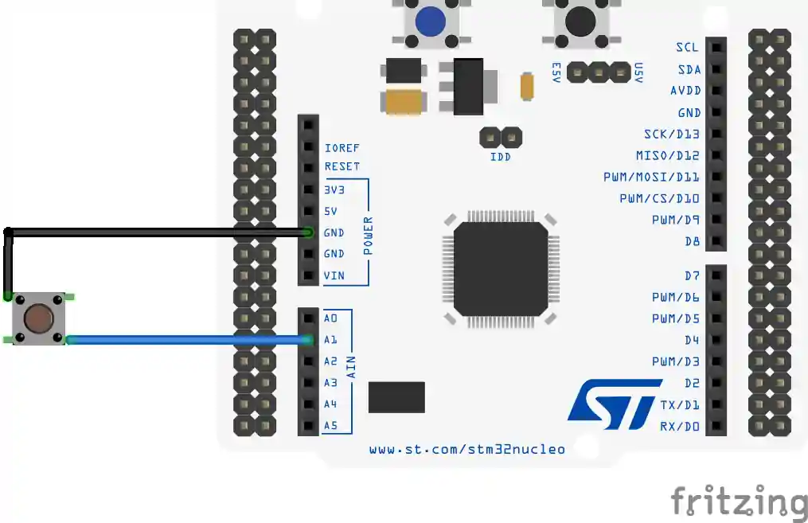

Fig 2: STM32 MICROCONTROLLER
https://controllerstech.com/wp-content/uploads/2020/12/gpioinput2.webp

2.4 Configuring/Installing Peripherals
- To start with Embedded AI design, installation of Embedded AI development tool chain is mandatory.
- In this the main tool for designing is NanoEdge AI Studio and the programming part requires Arduino 1.8.19
- The codes required for the hardware interfaces are taken from different url’s mentioned by the instructor like:
shorturl.at/fmvJO- where codes for LED interfacing are available.
- Different libraries are also included in the Arduino which are required for the interfacing and hardware purposes.

2.5 Applications
- Analog/digital design using discrete components.
- Designing PCB with micro-controllers, wireless interfaces, energy harvesting and sensors and test on the field.
- Firmware implementation for low power and application.
- High-level software programming, machine learning, wireless communication.
- Used for LCD’s.
- Different audio signals can be detected and identified.
- Different vibrations and motions can be detected according to the requirements.

2.6 Advantages & Disadvantages
Advantages:
- They are very compact in size, with high speed.
- Embedded Systems are very reliable.
- They consume less power and electricity, and they also perform task and operations assigned to them with great accuracy.
- They are built to perform special task and operations given to them.
- They can be customized for producing more enhanced results.

Disadvantages:
- The Embedded Systems are very tedious and difficult to upgrade and update.
- Requires lot of time and energy to maintain these systems.
- They are not associated microprocessor or microcontroller for processing.
- If system get damage or corrupt they are completely changed and removed.

CHAPTER 3
INTERNSHIP DISCUSSION
  - How the objectives achieved?
- Installation of Embedded AI development tool chain
- Hands on Labs using STM32 GPIO- on board LED and Button.
- Introduction to Sensor Technology.
- Detection and identification of different audio signals.
- Detection and identification of different vibrations and motions using sensors.

  - What skills (scientific and professional) were learned during the internship?
- Installation of the tools required for the Embedded AI Design like NanoEdge AI Studio and Arduino.
- Working with Arduino for hardware implementation like blinking and button of LED and serial communication.
- Interfacing hardware using NanoEdge AI Studio.
- Different audio signals can be detected and identified using the tool.
- Analog signals are transmitted using the software and samples are generated.
- Different vibrations and motions signals can be detected using sensors.

3.3 Results/observations/work experiences get in the internship
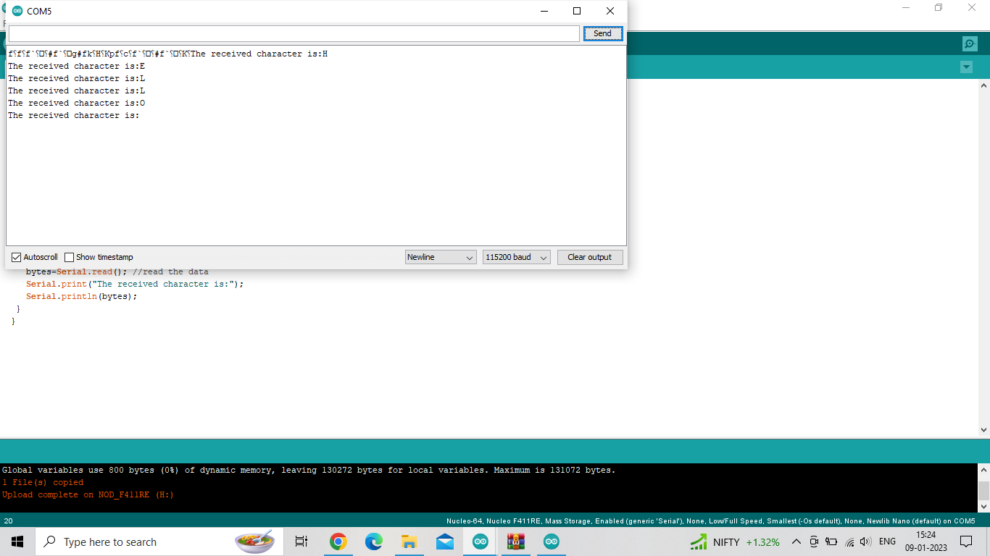
Fig 3: Serial Communication

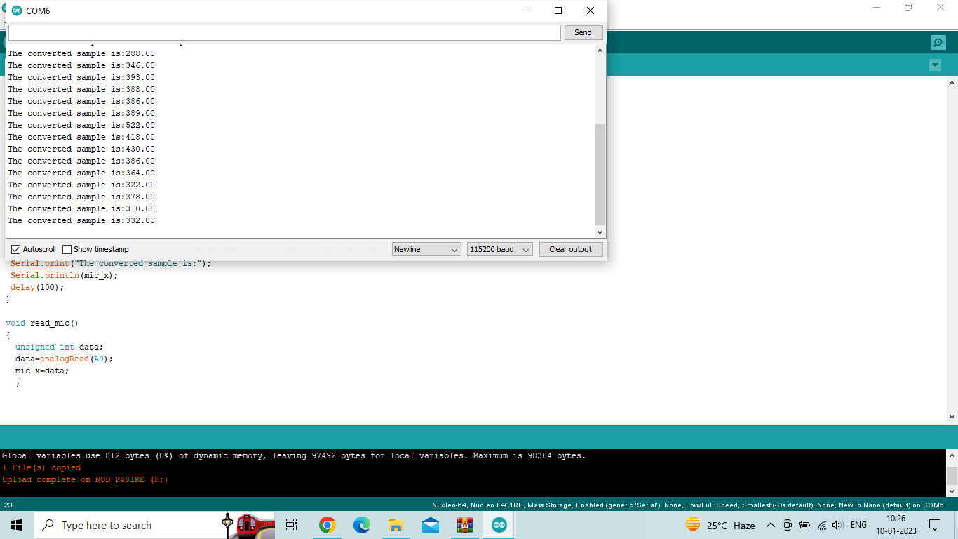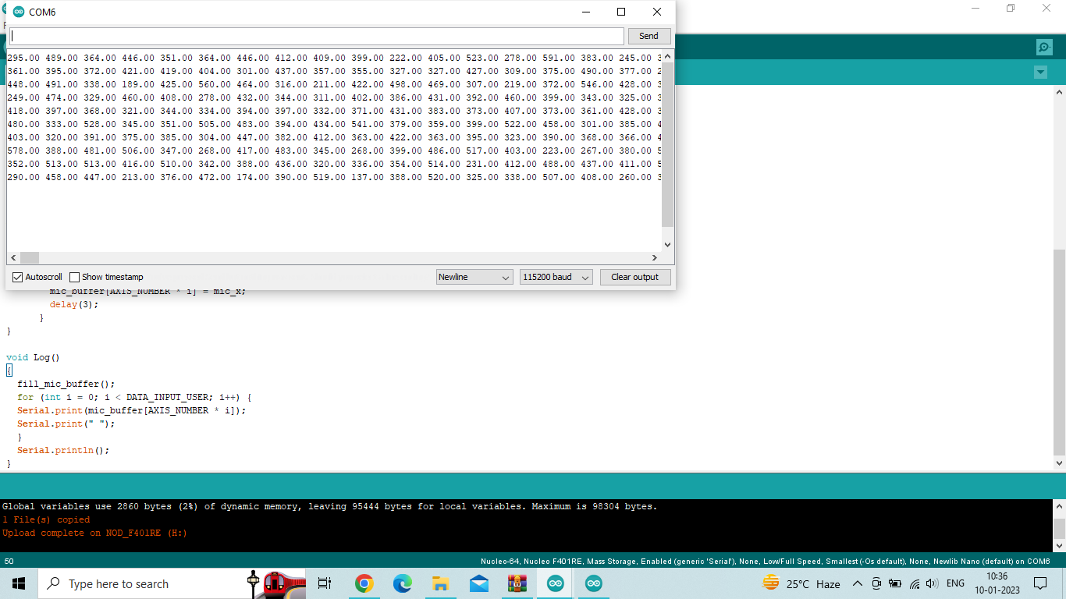
Fig 4: Samples for an Analog signal

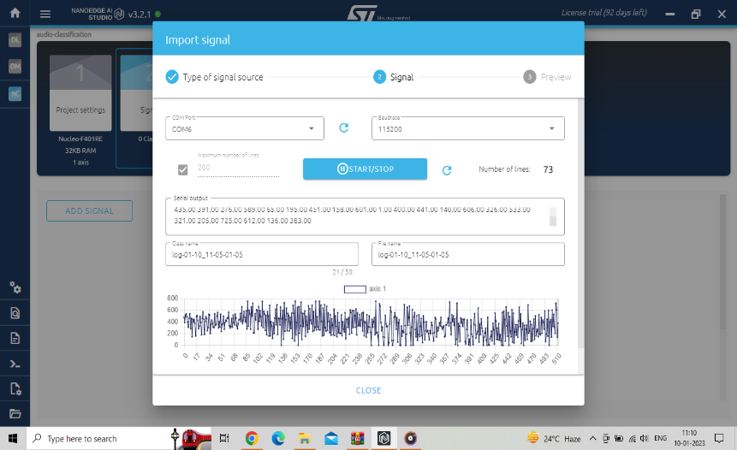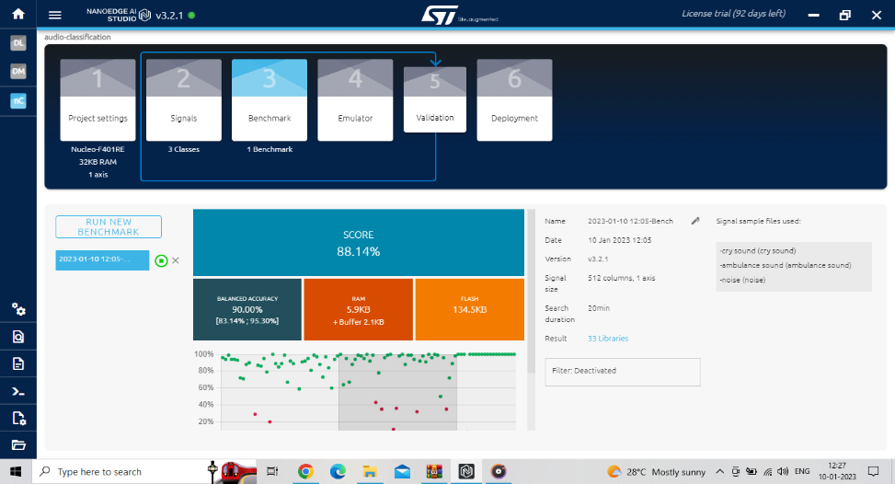
Fig 5: Collecting the signals Fig 6: Benchmark of the signals
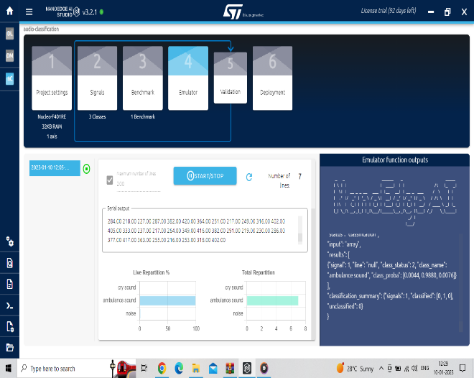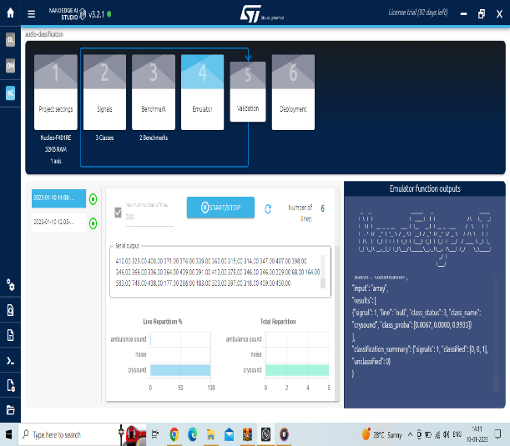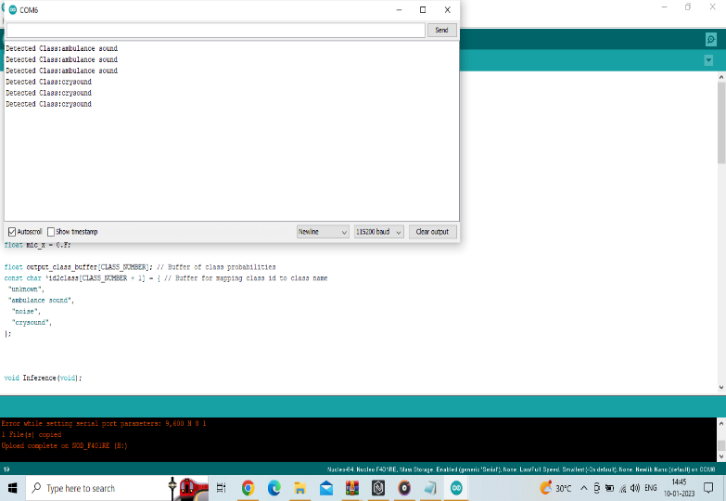
Fig 7: Detecting the sounds Fig 8: Output of sound detection

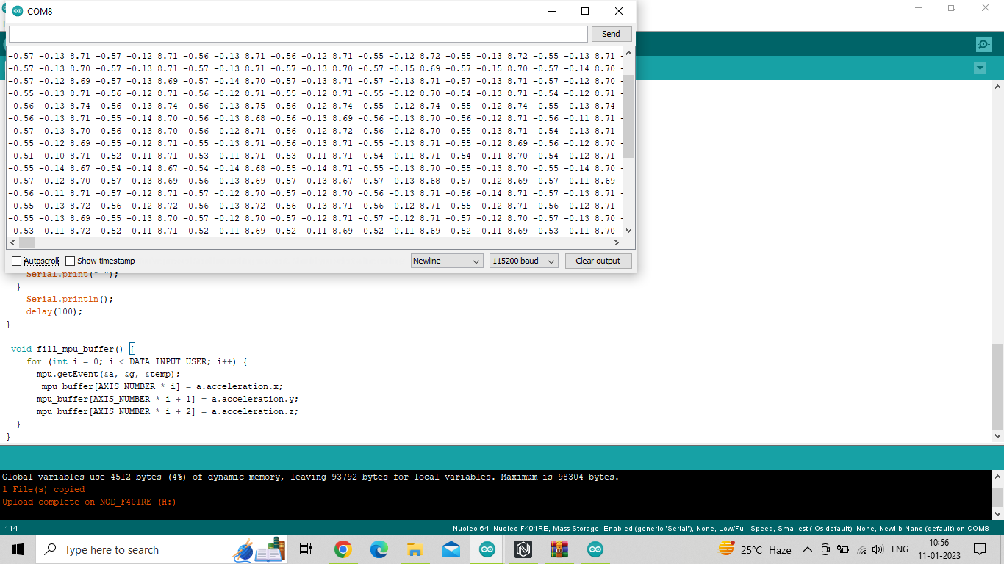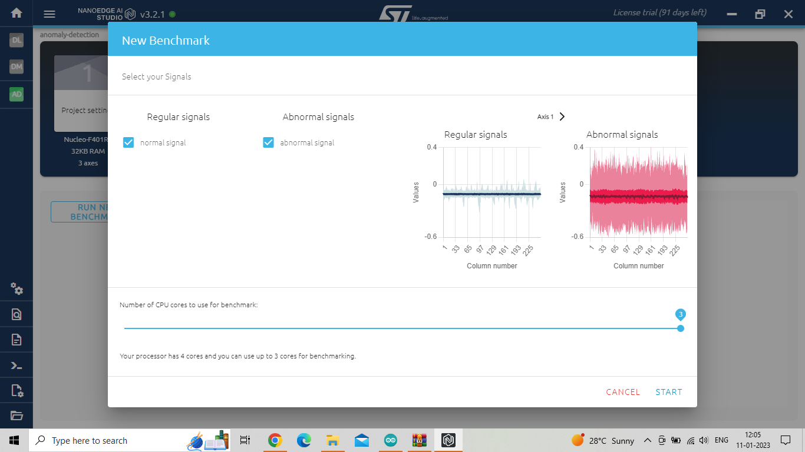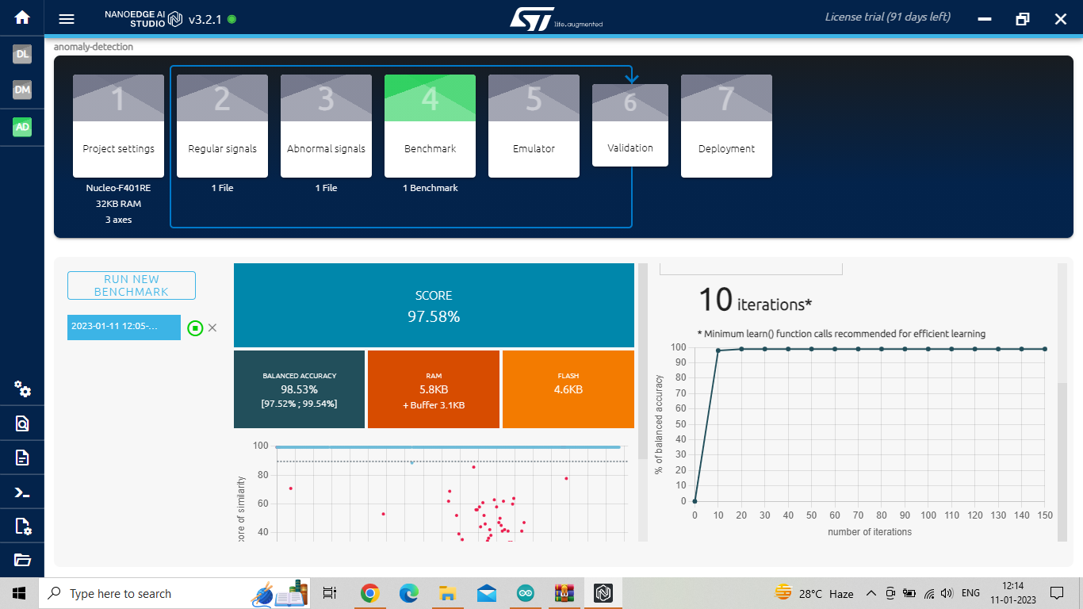
Fig 9: Vibration data generated Fig 10: Generated signals Fig 11:Benchmark score
samples
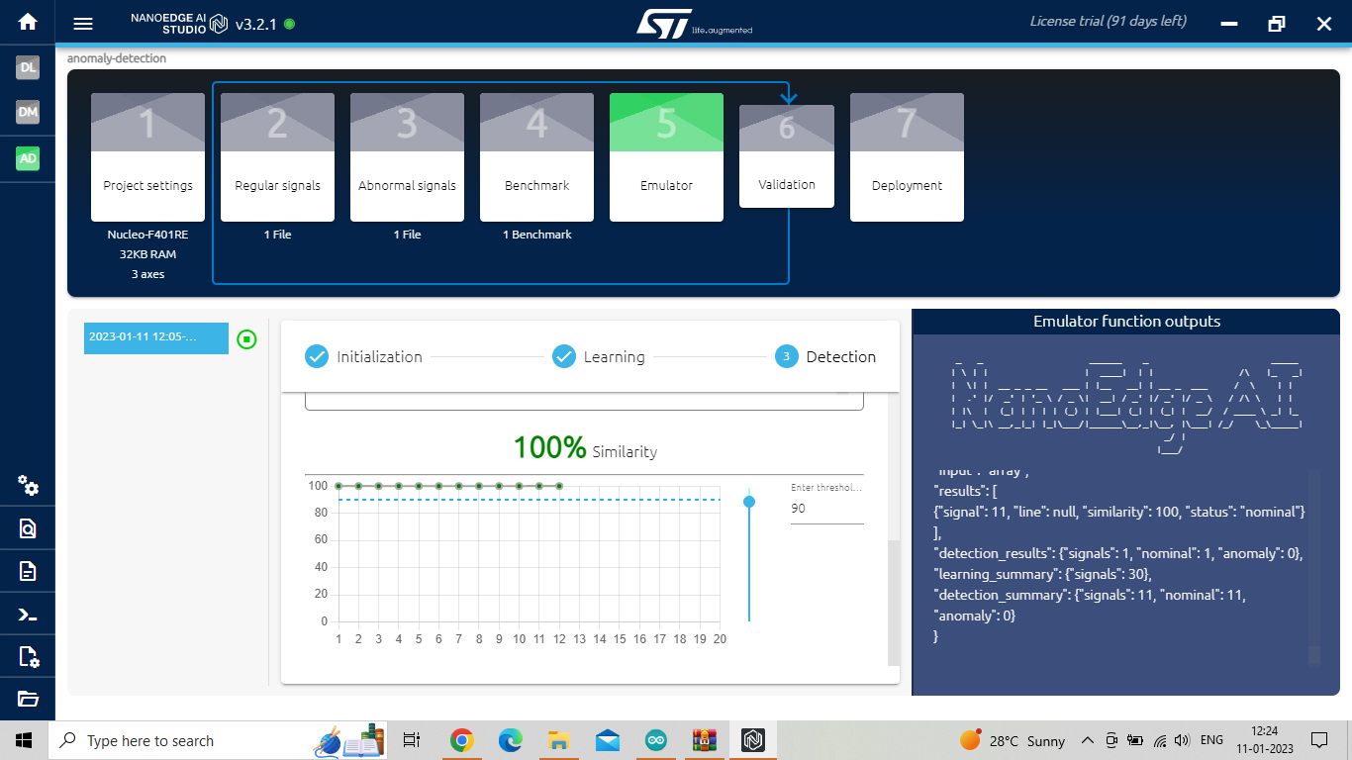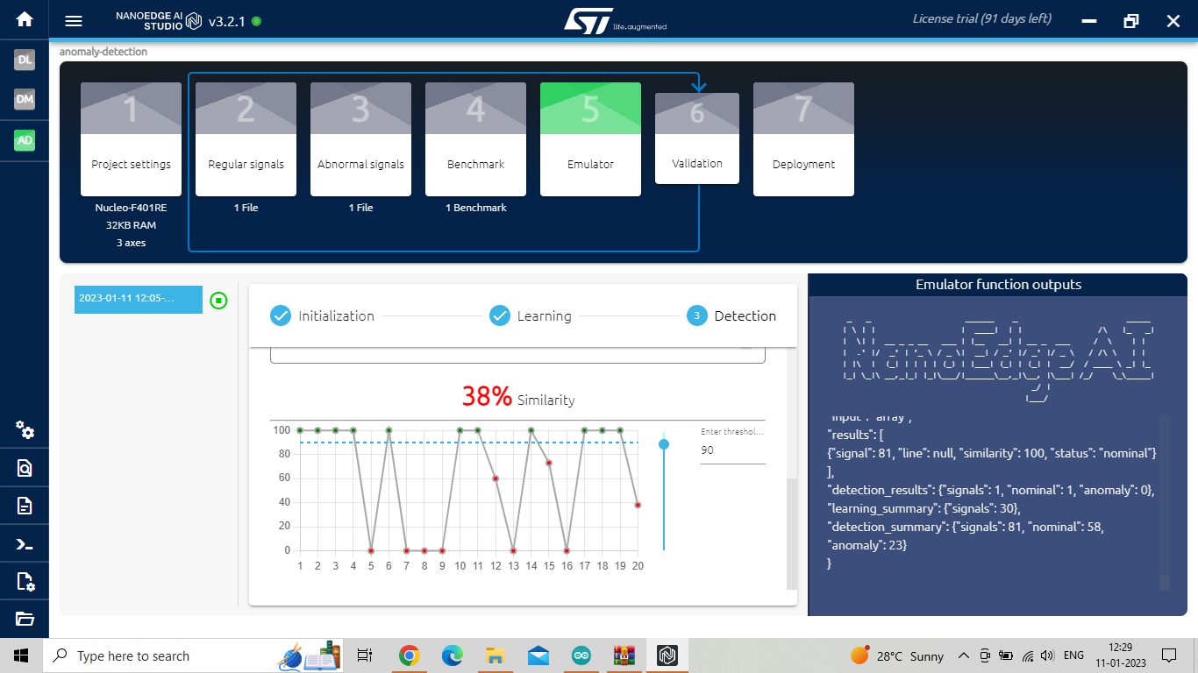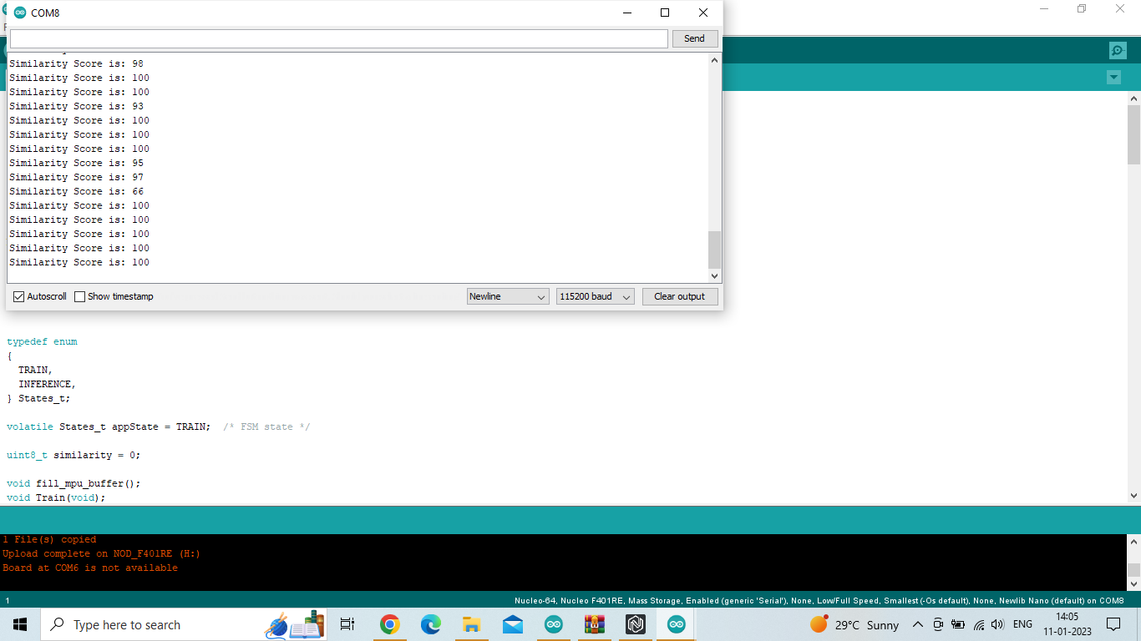
Fig 12: Emulator with similarity Fig 13: Emulator with Fig 14: Output in Serial
Dissimilarity Monitor
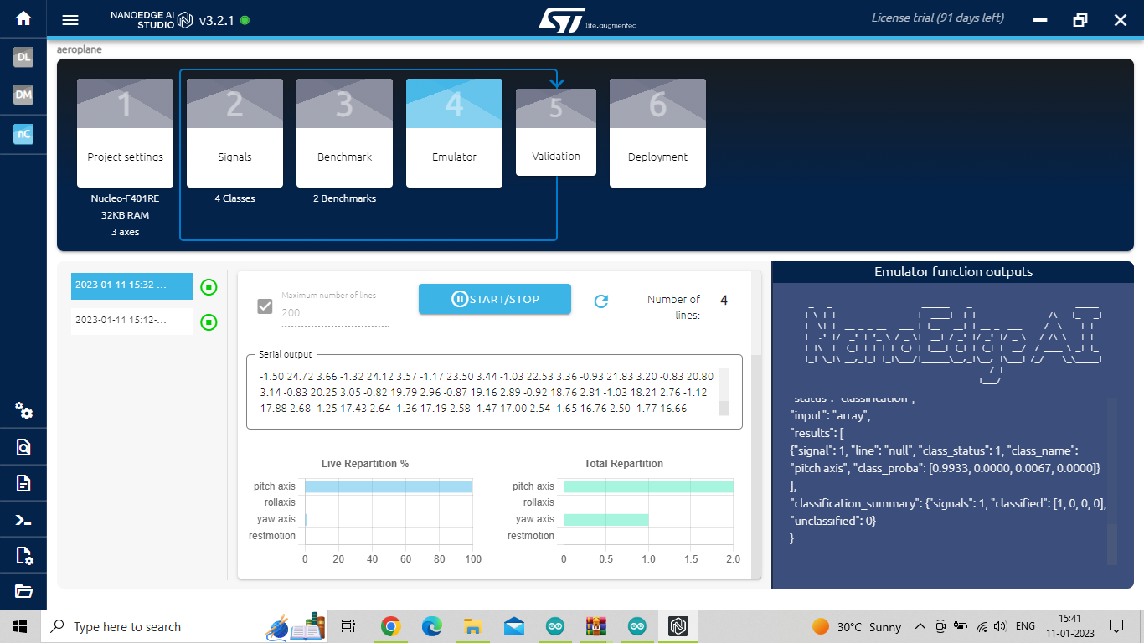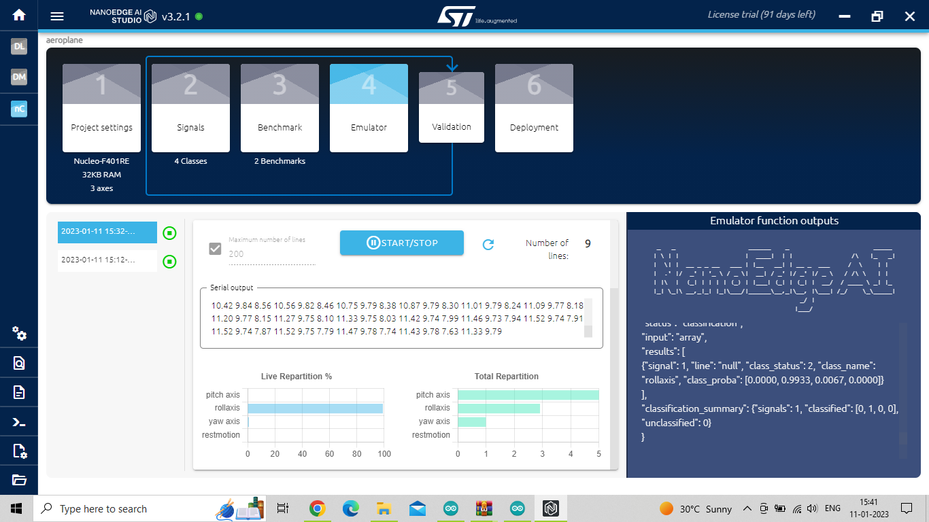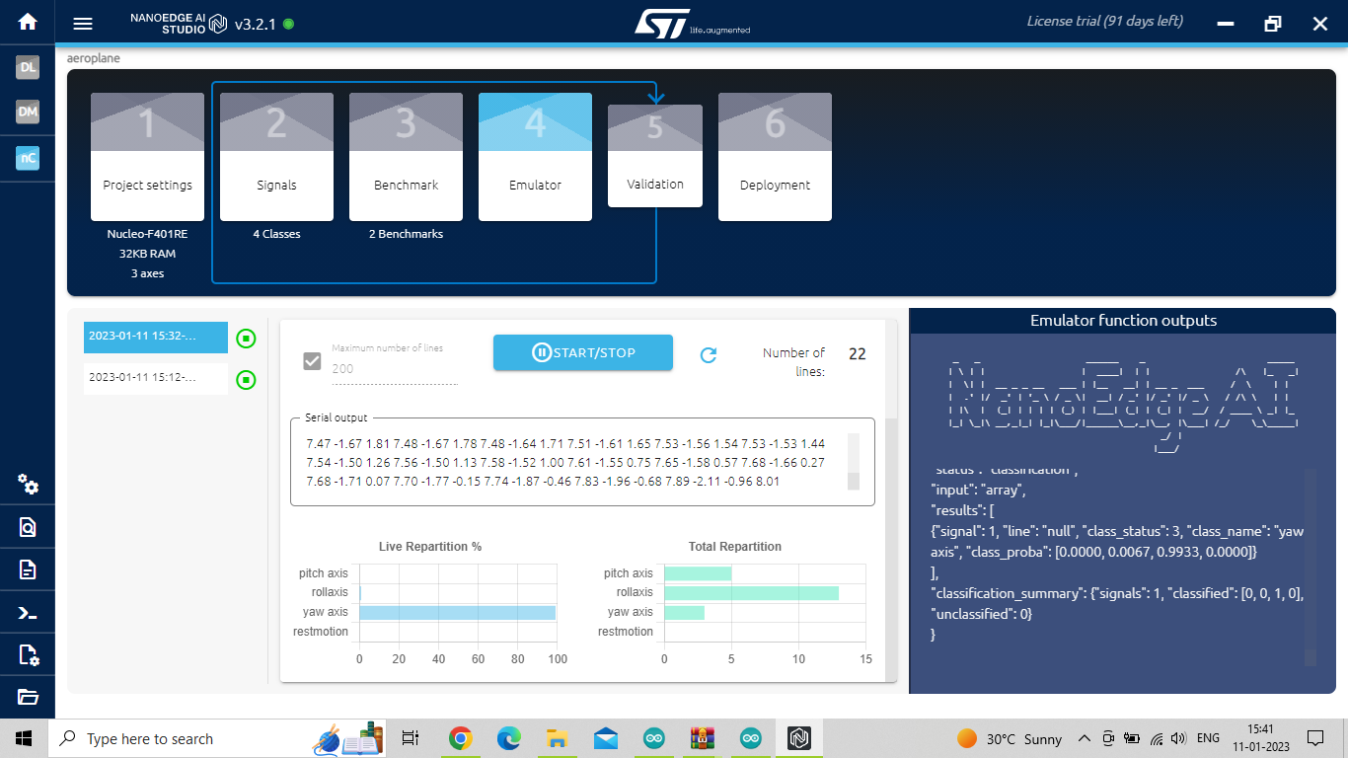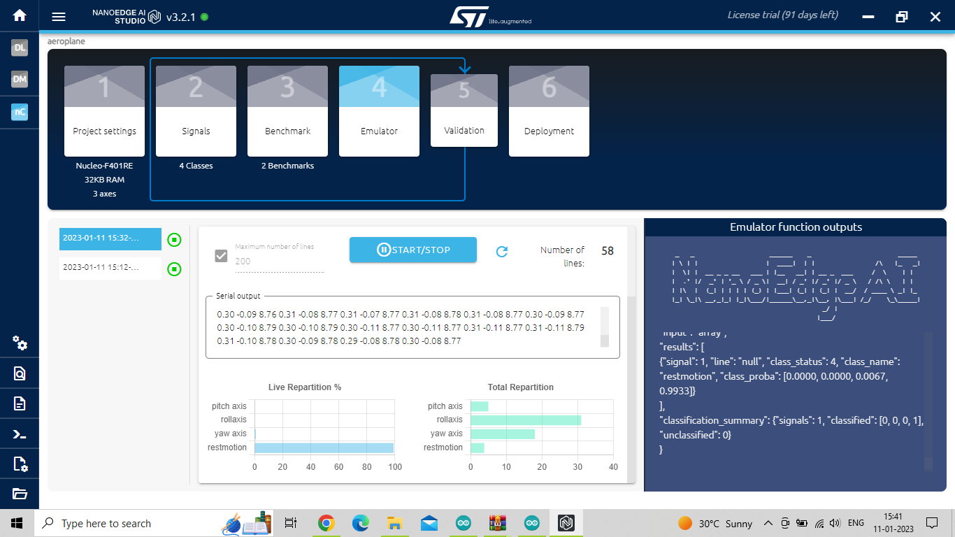
Fig 15: Emulator of Fig 16: Roll Axis Fig 17: Yaw Axis Fig 18:Rest Motion
Pitch Axis Emulation Emulation

  - What challenges did you experience during the internship?
- The problem with the internship is that the tool used in the designing is licensed and the components used in the interfacing are not affordable if they are damaged.
- The installation takes more time in case of NanoEdge AI Studio.
- Detecting the samples maybe be difficult if there is external noise.
- There maybe problems in the cables for connections may become loose in the process of detection of signals.

CHAPTER 4
CONCLUSIONS
- Embedded AI Design is performed using tools like NanoEdge AI Studio and Arduino.
- Interfacing using Arduino, STM32 and NanoEdge AI Studio is achieved.
- Different audio signals are detected and identified using the tool.
- Different vibrations and motion signals can be identified and detected using sensors.

REFERENCES
[Only in IEEE Format]
[1]. Andrew N. Sloss, Dominic Symes and Chris Wright (2008), ARM Systems Developer’s Guides - Designing & Optimizing System software, Elsevier, New Delhi, India.
[2]. Mohamad Hazwan Mohd Ghazali and Wan Rahiman, Vibration Analysis for Machine Monitoring.
[3]. Sara Anastasia , Marianna Madonnab , Luigi Monicaa, Implications of Embedded Artifical Intelligence.

